District 26 Cruise and Rendezvous Registration Form

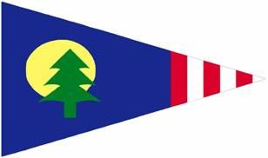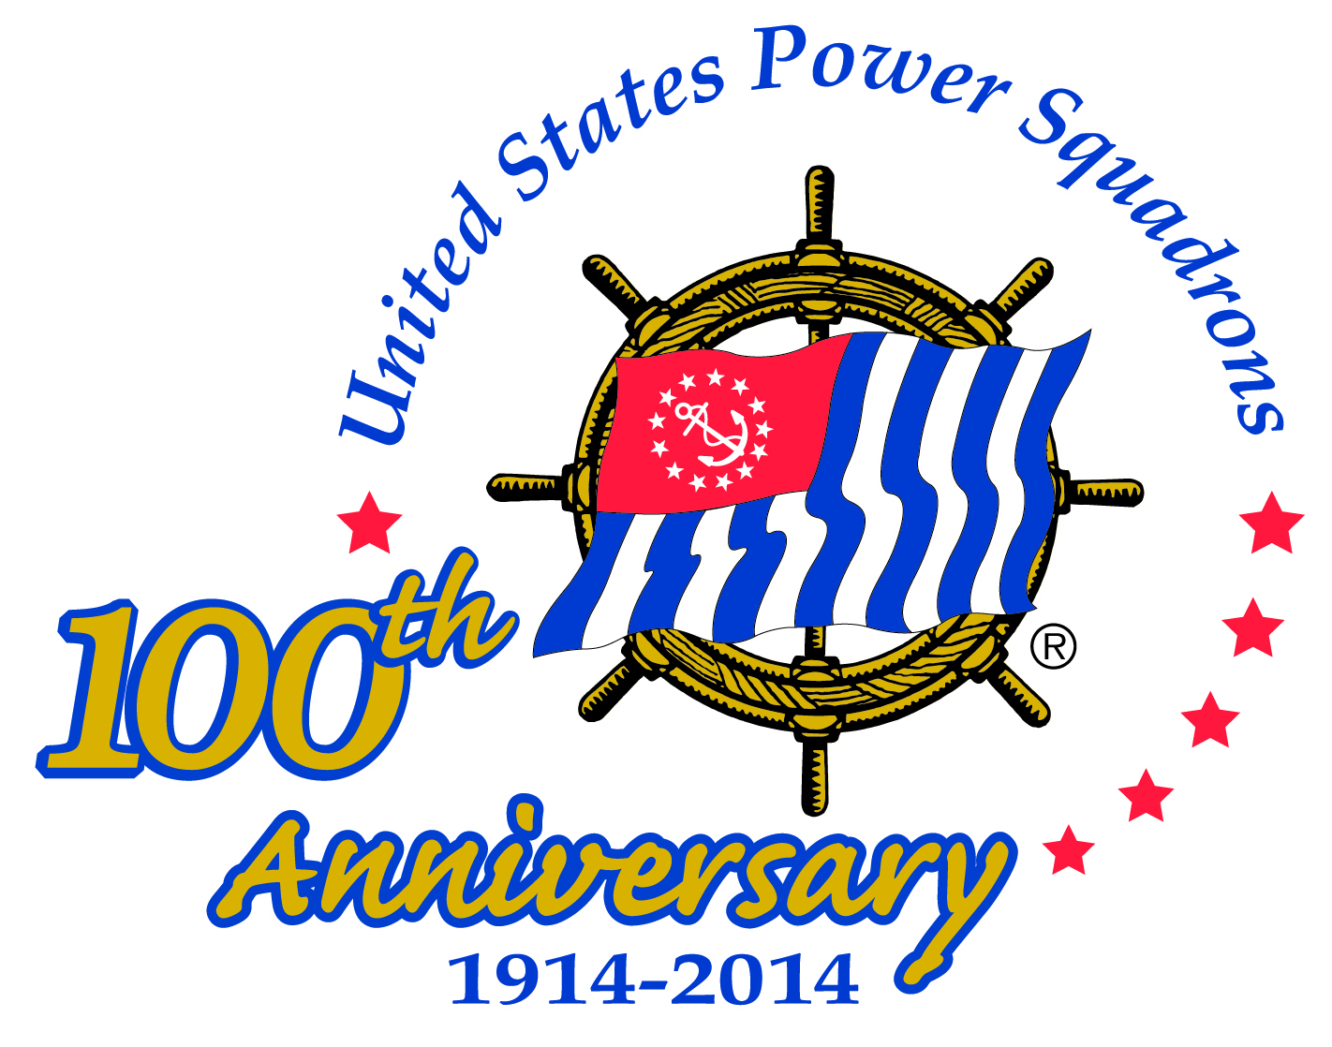

May 16, 17, 18, 2014, Thurmond Lake, McCormick County, SC

|  |  |  |  |  |
| --- | --- | --- | --- | --- |
| Last Name/Grade | First Name | Telephone | Email Address | Saturday Dinner Entrée |
|  |  |  |  |  |
|  |  |  |  |  |

|  |
| --- |
| Friday, 16-May  1600-1800 Registration in Cove Room, Savannah Lakes Resort, 101 Village Drive, McCormick SC  Hospitality Room and Silent Auction opens in Cove Room  1800-2100 Barbeque dinner on the deck _____# Attending @ $20 Total $_____ (Grilled chicken, pork BBQ on buns, cole slaw, baked beans, potato salad, peach cobbler, tea, and lemonade) |
| Saturday, 17-May  0700-0900 Continental Breakfast in Cove Room _____# Attending @$5 Total $_____  A hot breakfast bar is available at Hickory Knob State Park, main lodge, for $5.95 ++ (pay there)  0800-1100 9-Hole Ryder Cup Golf – Handicap - Male___ Female ___ @$30 Total $_____  0900-1200 Tour of National Wild Turkey Museum _____ # Attending @$5 Total $_____  Tour Thurmond Lake Visitors Center & Dam _____# Attending no charge  Tour of McCormick Heritage Gold Mine _____# Attending @$5 Total $_____  1200 Box Lunch, (Circle choice: Ham, Roast Beef, Pimento cheese spread, Chicken Salad )  ______# Needed @$12 Total $_____  1200-1500 Digital camera scavenger hunt  Meet at Savannah Lakes Resort Beach. _____ # Players @$5 Total $_____  I will / will not bring a boat (circle one). I can take _____crew on my boat.  I want to crew on a boat; _____# of crew.  1500 Picture judging, Savannah Lakes Resort Beach 1800-1900 Social Hour (cash bar) at Recreation Center, 385 Country Club DriveSilent Auction re-opens at Recreation Center1900-2200 Cruise and Rendezvous Banquet, Recreation Center, __# Attending @$35 Total $_____ *Baked tilapia or Flank Steak, Roasted Mushroom salad with creamy tarragon vinaigrette dressing, Garlic Mashed Potatoes, Broccoli and Cauliflower, Rolls & Butter, Tea & Coffee, Ice Cream and strawberries* |
| Sunday, 18-May  0900-1100, Brunch at D/C LeMond’s home, 205 Rosewood Lane # Attending _____ |
| Lodging:  Savannah Lakes Resort, 101 Village Drive, McCormick, $69+ tax, single or double  call (864 391-2152), Savannahlakesresort.net  Hickory Knob State Park, 1591 Resort Drive, McCormick $85 - $90, call 864 391-2450 after 15-April. |
| Marina slips: Savannah Lakes Resort, $15 uncovered, $28 covered, call 864 391-3477 |
| Launching Ramps: (Boat Trailer Parking at Savannah Lakes Resort)  US378; from McCormick, right off US378 just before Little River bridge.  Hickory Knob State Park; US378 to SC 7, left at park sign, left on Tackle Shop Road.  Little River Cottage Sites; US378, to Holiday Road at First Citizens Bank, right on New Years, ramp at end of New Years, limited parking. |

Mail completed registration form and check payable to TLSPS to:

Thurmond Lake Sail and Power, P. O. Box 1026, McCormick, SC 29835

-Save this page-

**Lodging** The Cruise and Rendezvous’ venue will be the Savannah Lakes Resort on Lake Thurmond. Proceed west from McCormick on US 378 for 6.4 miles and the Resort will be on the left. We will have registration, Friday’s dinner, the Hospitality Room and silent auction at the Resort on Friday. On Saturday at the Resort, we will offer a Continental breakfast, will meet there to begin the tours, will distribute the box lunches and start the Scavenger Hunt there also. There is no restaurant at the Resort.

Lodging is also available at the nearby (10-minute drive) Hickory Knob State Resort Park also on Lake Thurmond. From US378, turn onto SC 7 at the Village Store, proceed 2 miles and the park sign is on the left . The poolside rooms are near the lodge (3 miles in the park) that has a restaurant and gift shop. There is also golf, skeet, and tennis on the park. Reservations accepted after 15-April.

**Saturday morning events**

>A 9-hole *‘Fun’* Ryder Cup Golf at Monticello Golf Course. Da Men *vs*. Da Women. Slightly experienced golfers are welcome. If you do not have a handicap please indicate ‘none’ or ‘golf’’.

>The National Wild Turkey Winchester Museum is in nearby Edgefield, about a 45-minute drive from the Resort. The 7,200 square-foot facility tells the comeback story of the North American wild turkey.

>The Thurmond Lake Dam and Visitor Center is a 40-minute drive from the Resort. The Visitor Center has displays concerning the natural and cultural history of the area. The J. Strom Thurmond dam is included in the guided tour where you get a look at the power plant inside the dam.

>The Heritage Gold Mine Park is located in McCormick and includes original features of the 1850's mine. You can purchase buckets of ore to pan for gold, and screen for gemstones: keep what you find.

**Scavenger Hunt** We will meet at 1200 on Saturday at the Resort Beach to confirm boats and crew and to distribute detailed rules and maps. Each boat will be given a list of clues describing features visible from the lake within a defined section of the lake. When you find what the clue describes, take a DIGITAL picture of it AND record the picture number on the clue sheet. Be back at the beach by 1500. A judge will review the pictures with ONE member of each boat to score correct pictures. Targets unknown to players will be designated tie-breakers if two or more boats have the same number of correct pictures. Cash prizes will be awarded at the Banquet that night. Be sure to indicate on the Registration Form if you are bringing a boat or if you want to crew on a boat.

**The** **Saturday Night Cruise and Rendezvous Banquet** will be at the Recreation Center of Savannah Lakes Village, 385 Country Club Drive. From the Resort, go east on US378 to SC Highway 7, then go about 2.25 miles down SC7 to the second Country Club Drive. Turn in and the Center is on the right just up the hill. We will re-open the silent auction and have a social hour with a cash bar at 1800. Dinner and entertainment by Rhonda McDaniel (CBMA Female Vocalist of the Year for 6 Consecutive years) will follow with awarding of prizes from the Scavenger Hunt, and announcing the winners of the silent auction and dancing.

**Sunday Brunch** will be at the home of D/C Paula LeMond, 205 Rosewood Lane in Savannah Lakes Village. Go past the Recreation Center on Country Club Drive, turn left onto Magnolia Drive then right onto Apple. From Apple Lane, turn right onto Hickory Point then left onto Rosewood Lane.

**Hickory Knob**  For those who wish to come early or stay late. The park has a 3 day, 2 night golf getaway that includes: accommodations, two full breakfasts and three rounds of golf (Hickory Knob, Tara and Monticello) for $199 per person. Call the park at 1-800-491-1764 to book and for tee times.

**Foul Weather Plan** will be to cancel the Ryder Cup golf and scavenger hunt. After lunch, board games, a Bridge Tournament, ping-pong, bowling and card games will be offered at the Recreation Center for $1 per person; fitness center and pool for $4 per person. Bowling will be at cost.